# LOCAL PENSIONS PARTNERSHIP INVESTMENTS LIMITED

|  |  |
| --- | --- |
| **Lancashire County Pension Fund** |  |
|  | |
| **Pension Fund Committee** | **20 September 2019** |
| **Responsible Investment Report** |  |
|  |  |

|  |  |
| --- | --- |
| **Title of Paper** | Quarterly Report on Responsible Investment (2019 Q2) |
| **Lead Officer:** | Frances Deakin  Head of Responsible Investment  Local Pensions Partnership Investments Ltd  [frances.deakin@localpensionspartnership.org.uk](mailto:frances.deakin@localpensionspartnership.org.uk) |

1. Executive Summary

This report provides members of the Pension Fund Committee of Lancashire County Pension Fund (LCPF) with a quarterly update on Responsible Investment (RI) matters.

1. Introduction

The Fund's approach to RI is articulated within an Investment Strategy Statement (ISS) which confirms that the objective of RI is to decrease investor risk, improve risk-adjusted returns and assist the Fund's adherence to the UK Stewardship Code. LCPF’s ISS is supplemented by a Responsible Investment Policy which explains that the Fund's preferred approach to RI encompasses four main areas of activity:

* Voting Globally
* Engagement through Partnerships
* Shareholder Litigation
* Active Investing

Responsibility for the practical implementation of the Fund's approach to RI is devolved to Local Pensions Partnership Investments Ltd (LPPI) as LCPF's provider of investment management services. The report which follows provides the Committee with an update on RI activity during the period 1 April to 30 June 2019 plus insights on current and emerging issues.

1. Voting Globally

Through its investment in the LPPI Global Equities Fund (GEF) LCPF owns units in a pooled fund which invests in listed companies globally. Investors in the GEF delegate the control and exercise of shareholder voting to LPPI. This reflects that clients owning units in the GEF are beneficial owners in common but do not directly own shares in underlying companies.

LPPI exercises shareholder voting rights for the GEF centrally rather than delegating voting to individual asset managers and takes account of voting recommendations from an external provider of proxy voting and governance research (ISS) in accordance a Sustainability Voting Policy designed to ensure the consideration of ESG factors within analysis. LPPI reviews voting recommendations and takes the final decision on all voting.

In the second quarter of 2019 (the height of voting season) shareholder voting headlines for the GEF were as follows:

LPPI Global Equities Fund (GEF)

|  |  |
| --- | --- |
| Total company meetings taking place | 356 |
| Total resolutions  (management and shareholder proposals) | 4,819 |
| Total company proposals in the period | 4,641 |
| Total shareholder proposals in the period | 178 |

Company Proposals

|  |  |  |
| --- | --- | --- |
| Voting Supported Management | 4,161 | 90% |
| Voting Opposed Management | 480 | 10% |

Shareholder Proposals

|  |  |  |
| --- | --- | --- |
| Shareholder proposals supported by LPPI | 130 | 73% |
| Votes against shareholder proposals | 48 | 27% |

The following table summarises resolutions by type and indicates where opposition voting was concentrated in Q2.

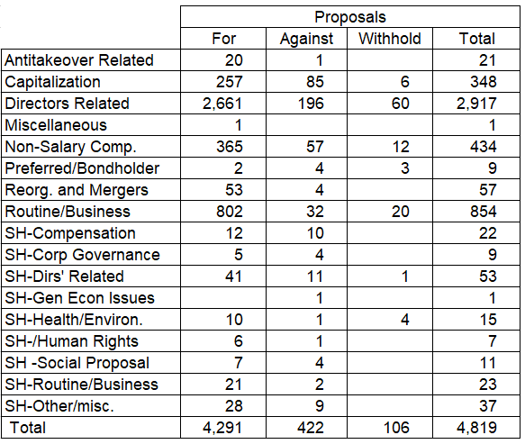

LPPI voted against or withheld support for management proposals in 480 instances (across 144 company meetings).

This included opposing 196 management proposals connected with the election / re-election of directors or with the appointment of statutory auditors.

Opposition voting commonly reflected concerns with the composition and independence of company boards as a whole, and with the independence of individual Board members as well as with over boarding (multiple other directorships) and an appropriate degree of detachment in the case statutory auditors.

Director Related

At Anheuser-Busch InBev (Belgium: Brewer) LPPI voted against the election/re-election of six out of seven directors due to their lack of independence, the Board currently contains only 20% independent directors. (Results: all 6 directors received support of +84%).

At China Everbright (Hong Kong: Investment Holding Co) and at Gaming and Leisure Properties Inc (US: Real Estate Trust) LPPI voted against the re-election of the incumbent Nominating Committee Chairs for a lack of gender diversity. Neither company Board currently has any female director representation. (Result:12.5% opposition and 23% opposition respectively). In the case of G&LP this level of opposition was notable given other nominees received 99% support.

At NTT DoCoMo (Japan: Wireless Telecommunication Services) LPPI voted against the appointment of four statutory auditor nominees on the basis that they held positions or had connections which represented an affiliation with the company and were insufficiently independent to be considered outsiders. The role of the statutory auditor in Japan is distinct from the more familiar roles of [external auditor](https://en.wikipedia.org/wiki/External_auditor) or [internal auditor](https://en.wikipedia.org/wiki/Internal_auditor). It is more akin to an audit & supervisory board membership and provides oversight. (Results: nominees received support of between 78% and 92%).

Non-Salary Compensation

Management proposals on compensation arrangements prompted 57 opposition votes. These were in reaction to examples of poor practices or weak corporate governance including inadequate information being released to shareholders and an incomplete disclosure of performance conditions, but also featured instances which provoked concern at the quantum of total rewards achievable.

At Metropole Television S (France: Broadcasting) LPPI voted against the compensation of four management board members. The company's current practices only allow shareholders to vote on a non-significant part of the management board members' remuneration, and the level of disclosure on performance conditions within the Long-Term Incentive Plan is below market standards. (Results: 10.7% against).

At Intel Corporation (USA: Semiconductors) LPPI voted against management on an Advisory Vote to Ratify Named Executive Officers' Compensation. This was on the basis of the magnitude of overall pay and compensation achievable under arrangements agreed for the new CEO appointed at the start of 2019. Were all performance criteria met in full, the new CEO’s compensation would significantly exceed the quantum of reward at comparable organisations and move considerably beyond the position of the prior CEO. (Result: 39.5% against).

At Yandex NV (Netherlands: Interactive Median & Services) LPPI opposed a proposal to amend the Equity Incentive Plan (agreed in 2016) on the basis that the plan would fall short on a number of best practice conditions. These include the vesting period (the time to be waited until shares are unconditionally owned by the recipient) being of insufficient length and non-executive directors being entitled to participate in the scheme. (Result: 27.2% against).

LPPI supported 130 shareholder proposals across 86 company meetings in Q2.

Familiar themes from prior proxy seasons continued to arise in 2019 with resolutions calling for:

* improved shareholder rights (one share one vote, reduced thresholds for calling meetings and submitting shareholder resolutions, proxy access /the right to nominate candidates);
* greater transparency (reporting on political lobbying, pay differentials, human rights within supply chains, climate change management and reporting on emissions reduction);
* corporate governance best practice (Separation of Chair and CEO roles, independent chairman, performance-linked remuneration, nomination practices to address board diversity and sustainability).

There were resolutions on gender pay gap reporting at 8 company meetings, including repeat proposals at both Facebook and Alphabet (Google) following a failure to receive adequate support in 2018 (a position ultimately repeated in 2019). At Facebook support was 9% down from 10% in 2018 and at Alphabet support was 11% down from 16% in 2018.

At Waste Connections Inc (Canada: Env & Facilities Services) LPPI supported a shareholder proposal seeking a formal written diversity policy and a report on plans to increase the representation of women on the board and among executive officers. Currently, Waste Connections has six directors, including one woman. Its eleven-member executive team includes one woman. The proposal received 64.5% support and passed.

At the Travelers Companies, Inc. (US: Property & Casualty Insurance) LPPI supported a shareholder proposal seeking a diversity report that would include the company's diversity policies, programs, and the gender and racial composition of the company's workforce. The intent was to have a reasonable basis for enabling shareholders to evaluate progress over time in advancing women and minorities to management or executive levels, something which is not currently supported by existing disclosure. The resolution received 50.3% support and passed.

The Alphabet AGM (USA: Interactive Media & Services) received 13 shareholder proposals on a range of themes, including issues of corporate governance, disclosure, shareholder representation and workforce protection. During 2018 unsatisfactory employment practices caused employees to raise concerns very publicly, specifically around sexual harassment. In response (and in with the context of negative media coverage) the company issued a conciliatory commitment to do better in future and a remediation plan which has seen a range of measures including a revamp of the company’s Policy on harassment , discrimination, retaliation, standards of conduct and workplace concerns. <http://services.google.com/fh/files/blogs/policy_workplace_concerns.pdf>

None of the shareholder proposals at Alphabet received majority support. Those receiving greatest support (+30%) related to shareholder representation and remuneration (governance issues) rather than broader social, ethical, environmental or employee-related concerns.

At Coca-Cola (US: Beverages) LPP supported a shareholder proposal calling for a report on the “Health Impacts and Risks of Sugar in the Company's Products” which received less than 5% support and at PepsiCo LPPI supported a proposal calling for a report on pesticide management which received 10% support.

Full details of the positions LPPI took on proposals voted at the Exxon Mobil AGM are reported elsewhere within the report, featured as part of an update on collaborative engagement connected with the investor initiative Climate Action 100+.

Members can view details of shareholder voting for all meetings via the LPP website where quarterly reports for the GEF are made publicly available.

<https://www.localpensionspartnership.org.uk/what-we-do/investment-management>

1. Engagement through Partnerships

LPPI regularly participates in collaborations which aim to make progress on commonly held issues by co-ordinating the efforts of multiple investors. Key partners include the Local Authority Pension Fund Forum (LAPFF) the Pensions and Lifetime Savings Association (PLSA) the Principles of Responsible Investment (PRI) the Institutional Investor Group on Climate Change (IIGCC) the LGPS Cross Pool RI Group, and the UK Pension Scheme RI Roundtable.

**LAPFF**

LAPFF has long been LCPF's preferred engagement partner. The Fund is a long-standing member of the Forum and the Head of Fund and Chair of the Pension Fund Committee both currently sit on the LAPFF Executive.

On a quarterly basis LAPFF provide a summary of the engagement activities undertaken on behalf of member funds which is available from the LAPFF website. <http://www.lapfforum.org/publications/qrtly-engagement-reports/>

Quantified across thematic topics, engagement by LAPFF in 2019 Q2 was as follows:

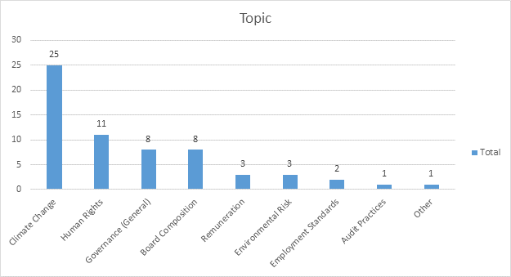

Of 62 companies engaged with by LAPFF in Q2, 12 companies (highlighted below in blue) are held within the LPPI Global Equities Fund in which LCPF owns units.

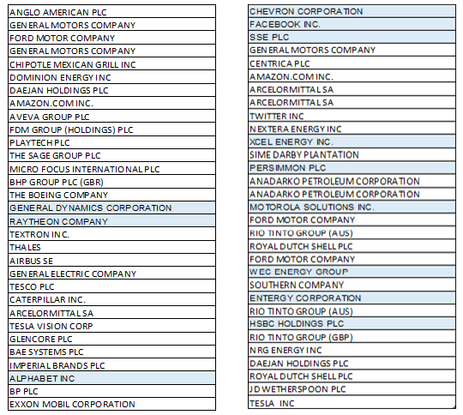

An overview of activity undertaken and outcomes to date (by company) is provided below.

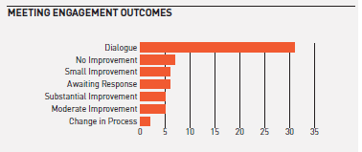

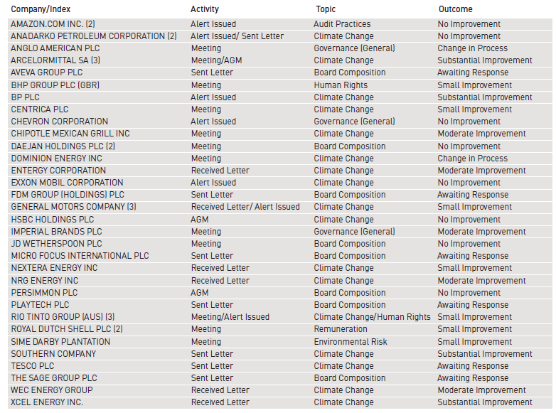

The predominant theme in Q2 was climate change which reflected a range of activities, most notably attendance at the AGM of steel company Arcelormittal (in Luxembourg) to urge the company to continue positive progress in planning for reduced emissions intensity and encourage the CEO to participate in the Energy Transition Commission which is focussed on accelerating the change towards low-carbon energy systems that enable robust economic development and limit the rise in global temperature to well below 2 degrees Celsius.

As part of ongoing engagement efforts, LPPI seeks appropriate opportunities to collaborate and regularly communicates with other parties including policy makers, advisory bodies, regulators, service providers and external asset managers as well as investee companies. The following matters are examples of collaborative engagement from Q2.

**Climate Action 100+ - Further Update on Exxon Mobil**

At its last meeting the Committee was appraised of next steps following Exxon Mobil’s conduct in relation to a shareholder proposal calling for short, medium, and long-term targets for emissions reductions in line with the Paris Agreement. LPP was one of 30+ investors who co-ordinated to co-file the proposal which was resisted by the company and ultimately did not appear on the ballot. This triggered an open exchange with CA100+ members around the authenticity of the company’s commitment to engaging with shareholders on climate change concerns.

The Exxon AGM held on 29 May 2019 was attended by a CA100+ representative who introduced and recommended shareholders give support to items 4 and 6. This was a clear and very public call for Exxon to emulate other oil and gas majors in committing to intensive, meaningful and independent director-led engagement with CA100+ on climate change without further delay.

The full results of shareholder voting at the AGM are set out below:

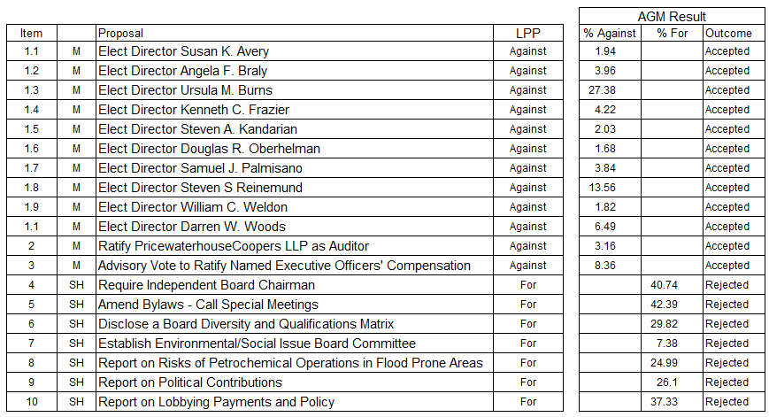

Elevated levels of dissent were seen, principally in relation to shareholder proposals, but the majority required to gain acceptance ultimately was not achieved. The separation of the role of Chair and Chief Executive received 40% support compared to 38% for the same proposal in 2018. In introducing this item to the AGM, the CA100+ spokesperson pointed to plain good governance and reiterated that “good governance supports good climate strategy and shareholder engagement”.

A proposal to require Exxon to provide information on public health risks through operations facing extreme weather events due to climate change-induced storms, flooding, and sea level rise gained 25% support. A call for the company to disclose information on each director’s gender and race/ethnicity, as well as their skills, experience and attributes most relevant to the company’s business, long-term strategy and risks received 30% support.

LPPI has continued to review and consider the position of Exxon Mobil within the GEF as part of ongoing monitoring. Exxon’s current ranking against the Transition Pathway Initiative (TPI) management quality measure is TPI 2 (building capacity). LPPI’s 2019 target for extractive companies is TPI 3 (operational integration) and where this is not achieved evidence of meaningful planning for the global transition to low carbon is required.

Exxon meet all requirements for TPI 3 other than forward targets for emissions reduction. The company have emphasised other measures which contribute to global climate change goals including

* announcing methane gas reduction targets and targets for a reduction in flaring
* joining the Oil & Gas Climate Initiative in late 2018 (alongside higher rated TPI Peers: BP, Shell and Total)
* a commitment to spending $5bn annually on environmental projects.

However, Exxon’s resistance to setting and publishing emissions reduction targets and delay/relative reluctance to support authentic engagement with CA100+ have also informed LPPI’s detailed discussions with the delegate manager holding Exxon stock. Consideration has been given to the long-term alignment of the company’s business strategy and its stance on climate change with LPP’s policy aims and the intent of the Paris Agreement. Within this context it was concluded that the GEF’s holding in Exxon Mobil should be liquidated and all shares in Exxon were duly sold by the end of June 2019.

**Investor Statement to G20 Summit**

Ahead of the G20 Summit in Osaka (Japan) in June 2019, LPP joined 477 investors managing over US $34 trillion to sign a statement urging world governments to:

* Achieve the Paris Agreement’s goals
* Accelerate private sector investment into the low carbon transition
* Commit to improve climate-related financial reporting.

The statement is an example of collaborative policy advocacy through which institutional investors are directly urging governments to institute the conditions in which investors will have confidence to shift portfolios towards the low carbon solutions fundamental to achieving the Paris Agreement targets. The full text of the investor statement is available via the following link.

<https://theinvestoragenda.org/wp-content/uploads/2019/07/190704-GISGCC-correction-3.pdf>

The investor statement was initially launched in June 2018 ahead of the G7 Summit and grew in scope and support ahead of the Global Climate Action Summit in September 2018 and COP24 in Katowice in December 2018.

**PLSA**

In the period since the Committee last met, the PLSA has published new best practice guidance for Pension Fund Trustees on ESG and Stewardship. <https://www.plsa.co.uk/Portals/0/Documents/Policy-Documents/2019/ESG-and-Stewardship-A-practical-guide-to-trustee-duties-2019-v2.pdf>

The Guidance offers comprehensive advice in advance of significant new requirements (from 1st October 2019) for Defined Benefit and Defined Contribution schemes to provide detailed disclosure on their policy for taking account of "financially material" considerations, including ESG factors, such as climate change. Multiple parties contributed to the development of the new guidance including the PLSA’s Stewardship Advisory Group (where LPP is represented). Ensuring user friendly and practical guidance is within the reach of trustees to help bust myths and support pension funds to comply with requirements is critical to both the take up and evolution of RI.

LGPS Funds are not presently subject to the new statutory requirements to provide detailed ESG disclosure – these relate to pension funds which publish a Statement of Investment Principles (SIP) - but the extension of equivalent requirements to the LGPS (via Investment Strategy Statements) should be considered highly likely and anticipated within short span.

1. **Shareholder Litigation**

LPPI employs Institutional Protection Services (IPS) as an external provider of litigation monitoring services to ensure shareholder litigation cases affecting securities owned by the GEF are known about, claims are filed in a timely way and progress is monitored and followed up with Claims Administrators. In addition, IPS monitor cases relating to shares held by LCPF in the period before the Fund pooled its listed equity investments from November 2016. Litigation can arise quite some time after shares have been sold and monitoring new cases and referring back to historic records to establish rights of ownership is an ongoing task.

IPS provide LPPI with monitoring information on a quarterly basis detailing the number of cases investigated. The monitoring report for Q1 2019 confirms that 4 new potential cases have been identified where the Fund may have an entitlement to join a class action and eligibility is being assessed, there are a further 2 cases where eligibility has been confirmed and a claim will be filed and 7 which have been discounted following further analysis. In Q1 the Fund received a disbursement of monies relating to one filed claim that has reached settlement.

1. **Active Investing**

The LCPF Responsible Investment Policy describes active investing as the search for sustainable investments which meet LCPF’s requirements for strong returns combined with best practice in ESG and corporate governance. The Fund has not set allocations for investments within specific sectors or identified impact themes but in general favours investments with positive social outcomes and has expressed an interest in understanding where current investments are delivering social benefits in addition to generating investment returns. Examples of socially positive investments are available from across the asset classes the fund invests in.

Within the RI section of its Annual Report for 2018/19 LPP has included information (pages 26-27) on four projects which are contributing wider social benefits in addition to investment returns - Guild Investments, Cape Byron, Forth Ports Group and Advent Life Sciences. The full Annual Report is available from the LPP website at the following link and provides wider context on LPP’s approach to RI. <https://www.localpensionspartnership.org.uk/Files/Files/LPP%20Annual%20Report%202019%20Final%20(DIGITAL).pdf>

Positive media coverage related to sustainability has been received in relation to an existing investment by GLIL in which the fund is a participating investor. Iona Capital (infrastructure manager) has contracted to purchase waste products from food manufacture which will be used by the Leeming bioenergy plant to generate sufficient energy (via anaerobic digestion) to power 800 homes per year (around 10,000 MWh of thermal power). The recent deal between Iona Capital and the Wensleydale Creamery has the additional benefit of diverting food waste away from being allowed to rot in landfill where it produces carbon-rich methane. Once the cheese by-product supplied by Wensleydale is converted into sustainable gas, what’s left at the end of the process will be fed onto neighbouring farmland to improve local topsoil quality.

Mike Dunn, co-founder of Iona Capital - "This shows the real impact of the circular economy and the part intelligent investment can play in reducing our carbon emissions.”

Iona Capital’s full press release on the arrangement is available from the following link.

<https://www.ionacapital.co.uk/single-post/2019/07/15/Iona-Capital-partnership-with-The-Wensleydale-Creamery-to-produce-energy-from-cheese>

The story was picked up by multiple publications including BBC local news, The Guardian and BusinessGreen.

**Other Insights**

New Resources

LPPI has recruited a new RI Analyst to its Investment Team. Paul Britton (based in the London office) joined in June 2019 to replace Clarisse Simonek who remains with LPP having transitioned into a deputy portfolio manager role in the Investment Strategy Team. Paul works directly with the Head of RI and will focus primarily on public market asset classes, including having day to day responsibility for the oversight of shareholder voting.

PRI Transparency Report Released

As reported to the Committee at its last meeting, in March 2019 LPP submitted a first set of detailed annual reporting to the Principles of Responsible Investment (PRI) having become a PRI signatory in July 2019. The PRI has now published 2019 Transparency Reports for all signatories via its website. LPP’s first detailed report against the PRI disclosure framework is available from the following link: <https://www.unpri.org/signatory-directory/local-pensions-partnership/3478.article>

Separately, each PRI signatory receives a confidential Assessment Report from the PRI which includes module scores which benchmark them against comparable signatories (peers) and offer a basis for tracking progress, identifying improvements over time and focussing development effort.

LPP received an A rating (highest band) for 4 out of 5 modules scored and a C for the fifth module. This is a very positive baseline from which to progress and evolve RI reporting going forward.

Through PRI reporting, LPP is releasing significantly more information into the public domain than on our approach (policy and governance) and activities (practical implementation) as a responsible asset owner on behalf of client pension funds. Whilst two other LGPS pools became PRI signatories in 2018 (Brunel and LGPS Central) LPP was the only LGPS pool to submit a report to the PRI by the 2019 deadline.

Additional Reporting – Taskforce on Climate Related Financial Disclosure

As part of the annual reporting process for 2018/19, LPP has fulfilled a commitment (within its RI Policy – Annex on Climate Change) to begin reporting in line with the final recommendations of the TCFD which encourage asset owners and asset managers to voluntarily disclose information on how their governance and operational arrangements integrate the identification and management of climate change.

LPP has taken first steps to begin disclosing in line with the TCFD recommendations via a report which accompanies the Annual Report and is available from the LPP website at the following link. <https://www.localpensionspartnership.org.uk/Admin/Public/DWSDownload.aspx?File=%2fFiles%2fFiles%2fReport+TCFD+Recommendations+v4.pdf>

LPP will produce updated TCFD reporting each year and is committed to extending future disclosure in step with the further development of investment practices on climate change and improvements in the quality and breadth of information available to give insights on investee companies.